Chapter 16, Problem 46.

Determine i_{o}(t) in the circuit in Fig. 16.69.

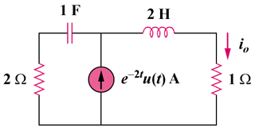

Figure 16.69
For Prob. 16.46.

